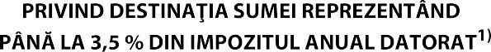



|  |  |  |  |
| --- | --- | --- | --- |
|  |  |  | 1 |

|  |  |  |  |  |  |  |  |  |  |  |  |  |
| --- | --- | --- | --- | --- | --- | --- | --- | --- | --- | --- | --- | --- |
|  |  |  |  |  |  |  |  |  |  |  |  |  |

|  |  |
| --- | --- |
|  | |
|  | |
| 36428530 | |
| ASOCIATIA AI VOINTA, AI PUTERE | |
| RO08RZBR00000600188970013 | |
| 3,5 |  |





